|  |  |  |  |  |  |
| --- | --- | --- | --- | --- | --- |
| Source | DF | Adj SS | Adj MS | F-Value | P-Value |
| Regression | 3 | 46.7724 | 15.5908 | 148.43 | 0 |
| Type of adhesives | 1 | 2.8981 | 2.8981 | 27.59 | 0.003 |
| Type of Fillers | 1 | 28.8643 | 28.8643 | 274.8 | 0 |
| Surface treatments | 1 | 15.01 | 15.01 | 142.9 | 0 |
| Error | 5 | 0.5252 | 0.105 |  |  |
| Total | 8 | 47.2976 |  |  |  |

Table 9. ANOVA table for specimens tested without shock exposure

Table 10. ANOVA table for specimens tested after 50 cycles of shock exposure

|  |  |  |  |  |  |
| --- | --- | --- | --- | --- | --- |
| Source | DF | Adj SS | Adj MS | F-Value | P-Value |
| Regression | 3 | 16.7602 | 5.5867 | 71.51 | 0 |
| Type of adhesives | 1 | 1.9837 | 1.9837 | 25.39 | 0.004 |
| Type of Fillers | 1 | 0.7004 | 0.7004 | 8.97 | 0.03 |
| Surface treatments | 1 | 14.076 | 14.076 | 180.18 | 0 |
| Error | 5 | 0.3906 | 0.0781 |  |  |
| Total | 8 | 17.1508 |  |  |  |

Table 11. ANOVA table for specimens tested after 100 cycles of shock exposure

|  |  |  |  |  |  |
| --- | --- | --- | --- | --- | --- |
| Source | DF | Adj SS | Adj MS | F-Value | P-Value |
| Regression | 3 | 28.686 | 9.5621 | 41.09 | 0.001 |
| Type of adhesives | 1 | 2.03 | 2.03 | 8.72 | 0.032 |
| Type of Fillers | 1 | 9.077 | 9.0774 | 39.01 | 0.002 |
| Surface treatments | 1 | 17.579 | 17.5788 | 75.54 | 0 |
| Error | 5 | 1.164 | 0.2327 |  |  |
| Total | 8 | 29.85 |  |  |  |

Note: “DF” represents “Degrees of freedom”, “Adj SS” represents “Adjacent Sum of Squares”, “Adj MS” represents “Adjacent Mean Sum of Squares”, “F-value” represents “Fischer value”, and “P-value” represents “Probability value”.

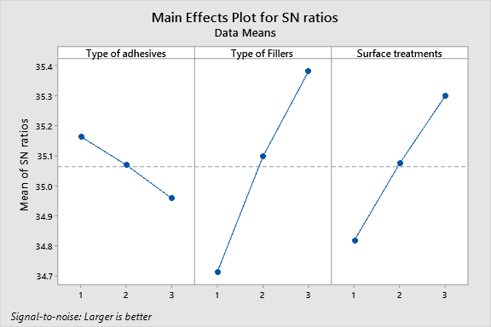

Figure 12. Main effect plot for the specimens tested without shock exposure

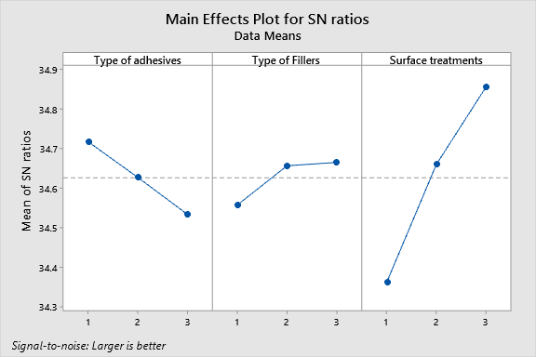

Figure 13. Main effect plot for specimens tested after 50 cycles of shock exposure

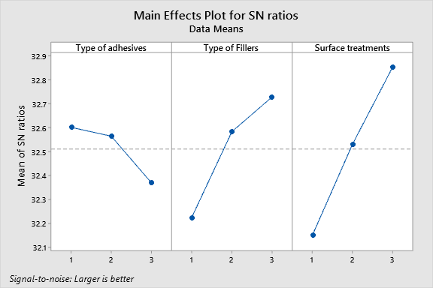

Figure 14. Main effect plot for specimens tested after 100 cycles of shock exposure

C:\ACADEMICS\VIT RESEARCH\Adhesion studies\Images\Minitab plots\9a.tif

Surface treatments

Type of Fillers

Type of adhesives

(a)

C:\ACADEMICS\VIT RESEARCH\Adhesion studies\Images\Minitab plots\9b.tif

Surface treatments

Type of Fillers

Type of adhesives

(b)

C:\ACADEMICS\VIT RESEARCH\Adhesion studies\Images\Minitab plots\9c.tif

Surface treatments

Type of Fillers

Type of adhesives

(c)

Figure 15. a) Optimized plot for specimens tested before shock exposure, b) Optimized plot for specimens tested after 50 cycles of shock exposure, c) Optimized plot for specimens tested after 100 cycles of shock exposure